CSA1405-COMPILER DESIGN LAB PROGRAMS

NAME: M. KANISHKA
REG.NO:192521283

Exp. No. 1
Develop a lexical Analyzer to identify identifiers, constants, operators using C program.

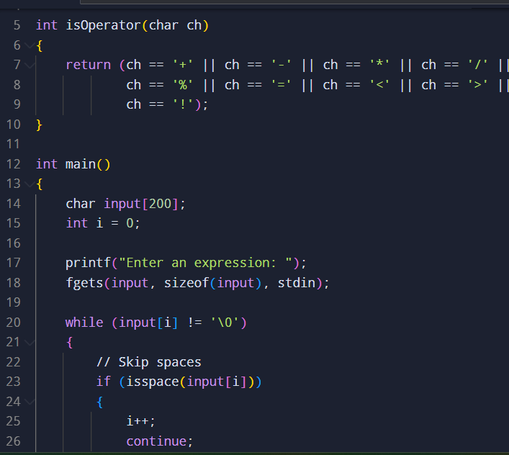
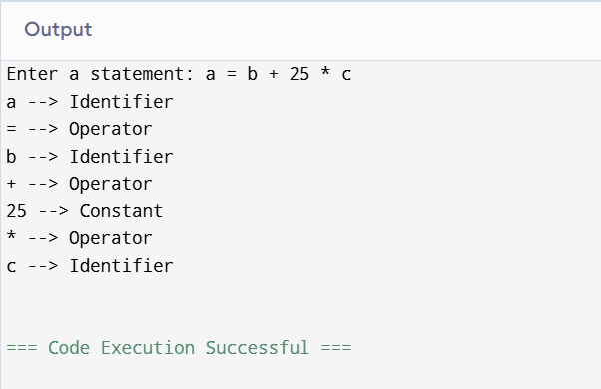

Exp. No. 2
Develop a lexical Analyzer to identify whether a given line is a comment or not using C
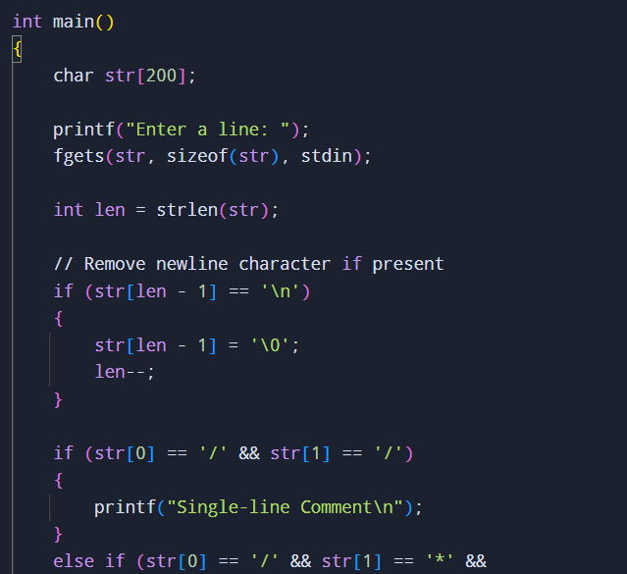

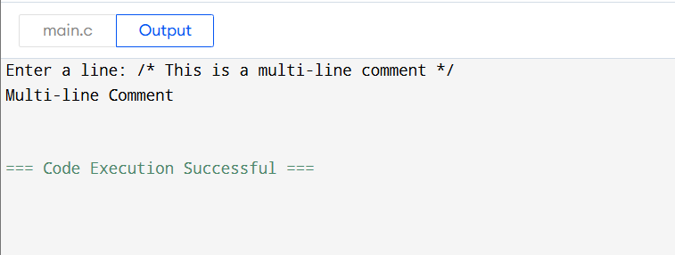

Exp. No. 3
Design a lexical Analyzer for given language should ignore the
redundant spaces, tabs and new lines and ignore comments using C
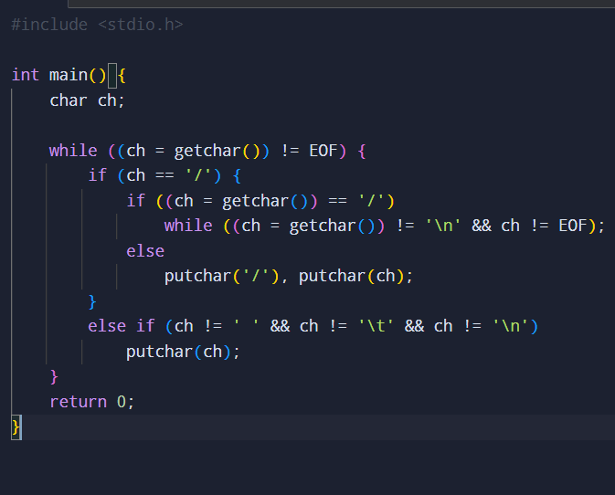
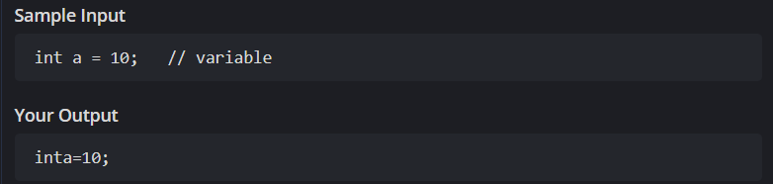

Exp. No. 4
Design a lexical Analyzer to validate operators to recognize the operators +,-,*,/ using regular arithmetic operators using C
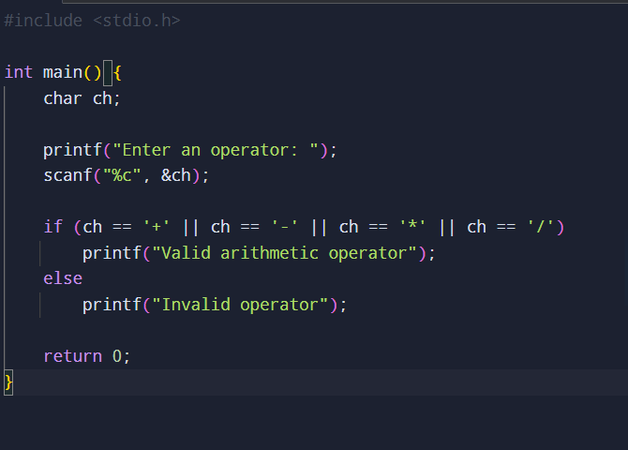
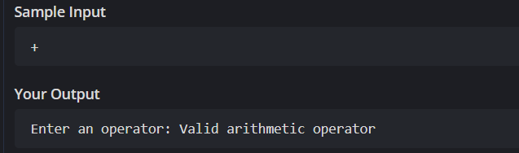

Exp. No. 5
Design a lexical Analyzer to find the number of whitespaces and newline characters using C.
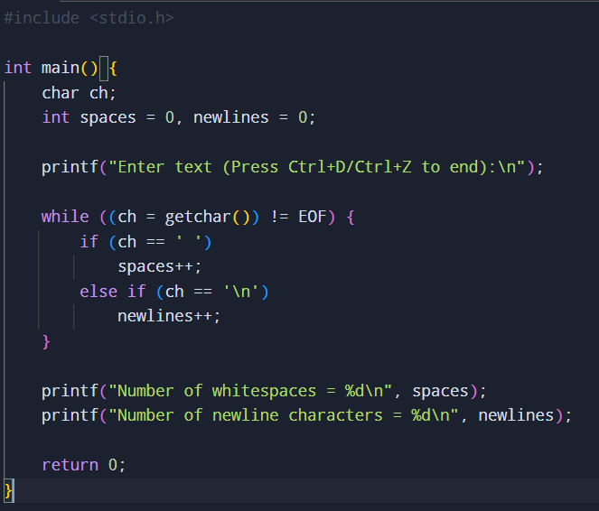
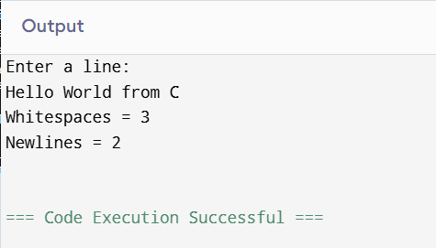

Exp. No. 6
Develop a lexical Analyzer to test whether a given identifier is valid or not using C.
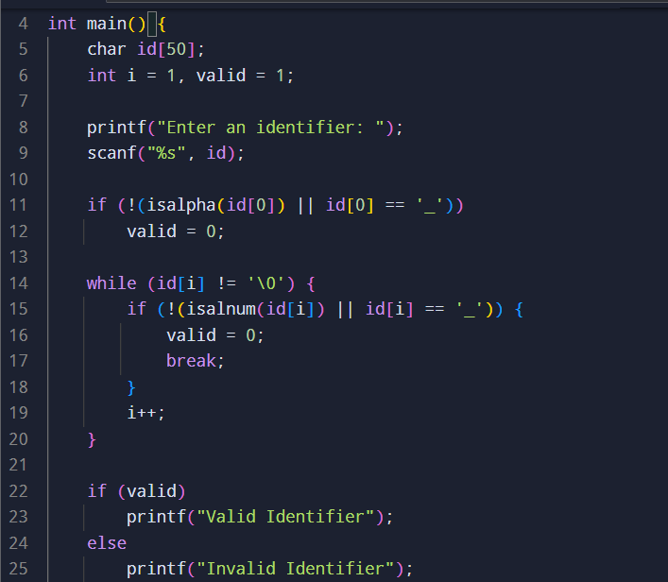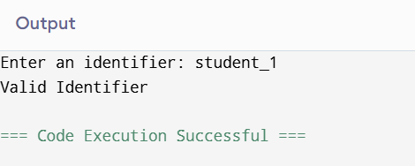

Exp. No. 7
Write a C program to find FIRST( ) - predictive parser for the given grammar
S → AaAb / BbBa
A → ∈
B → ∈
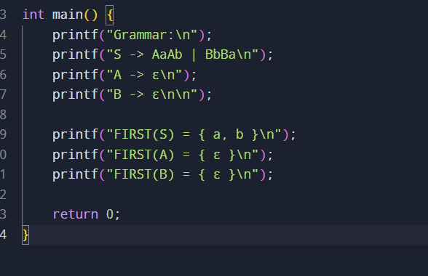
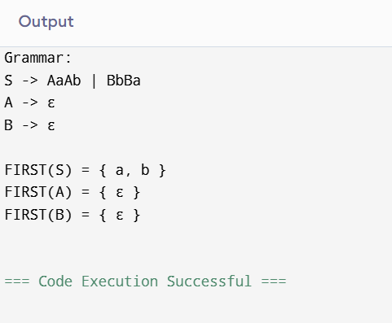

Exp. No. 8
Write a C program to find FOLLOW( ) - predictive parser for the given grammar
S → AaAb / BbBa
A → ∈
B → ∈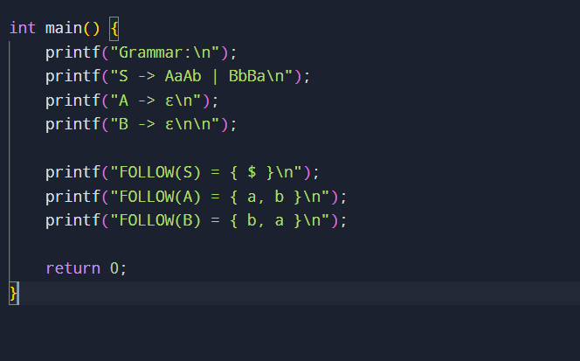
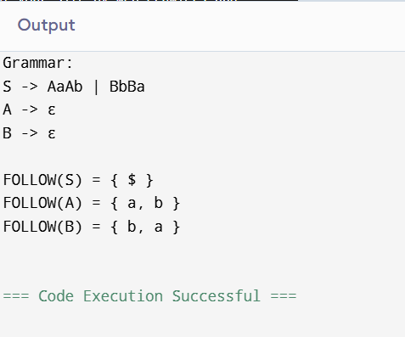

Exp. No. 9
Implement a C program to eliminate left recursion from a given CFG.
S → (L) / a
L → L , S / S
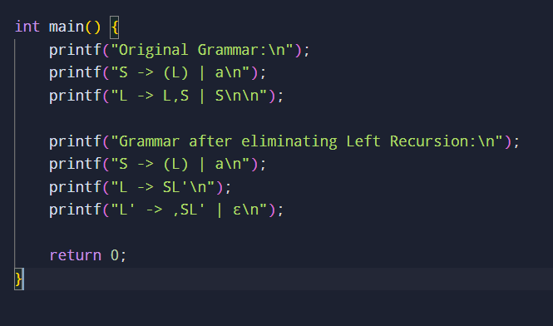
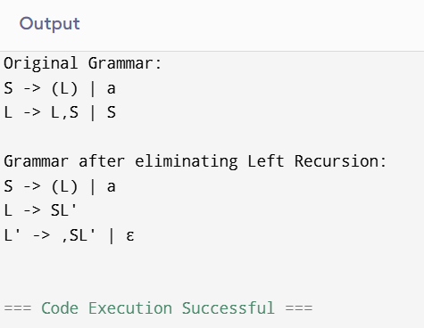

Exp. No. 10
Implement a C program to eliminate left factoring from a given CFG.
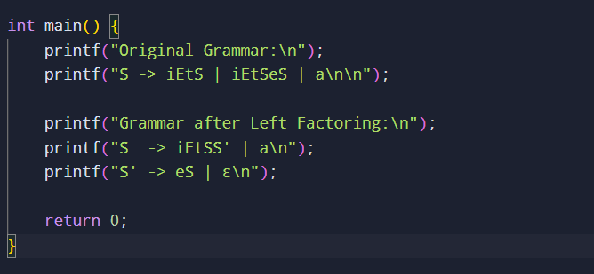
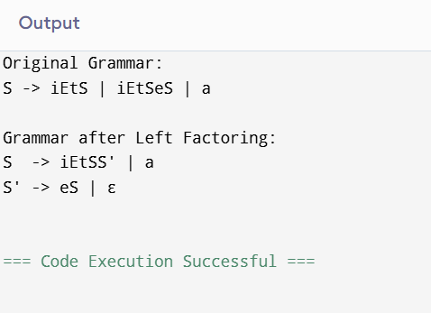

Exp. No. 11
Implement a C program to perform symbol table operations.
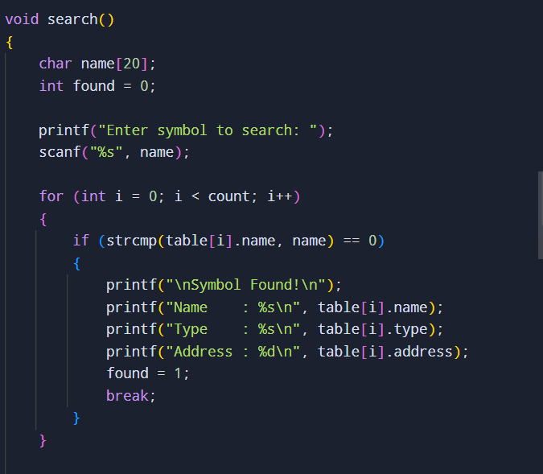
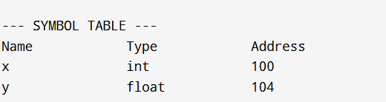

Exp. No. 12
Write a C program to construct recursive descent parsing for the given
grammar
E → TE’
E’ → +TE’ / ∈
T → FT’
T’ → *FT’ / ∈
F → ( E ) / id
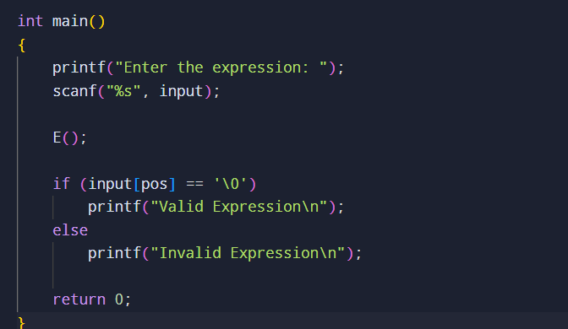
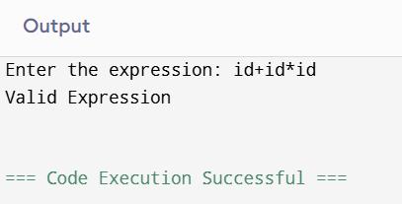

Exp. No. 13
Write a C program to implement either Top Down parsing technique or
Bottom Up Parsing technique to check whether the given input string
is satisfying the grammar or not.
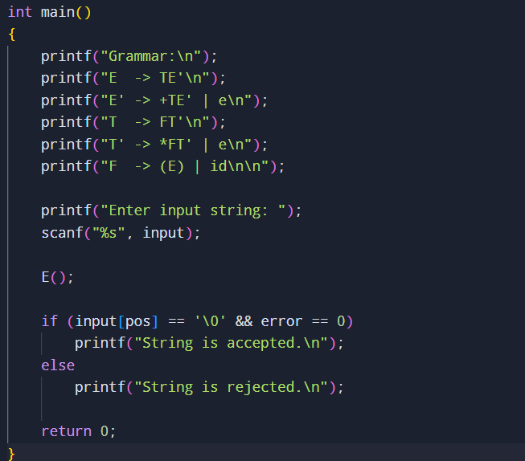
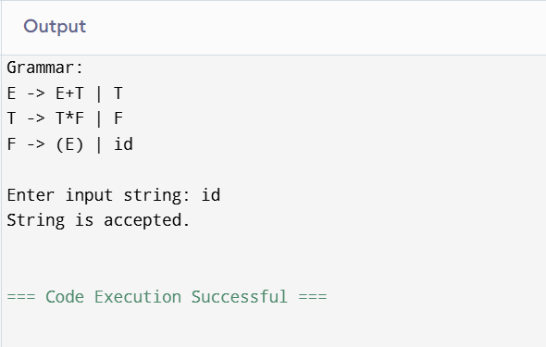
Exp. No. 14
Implement the concept of Shift reduce parsing in C Programming.
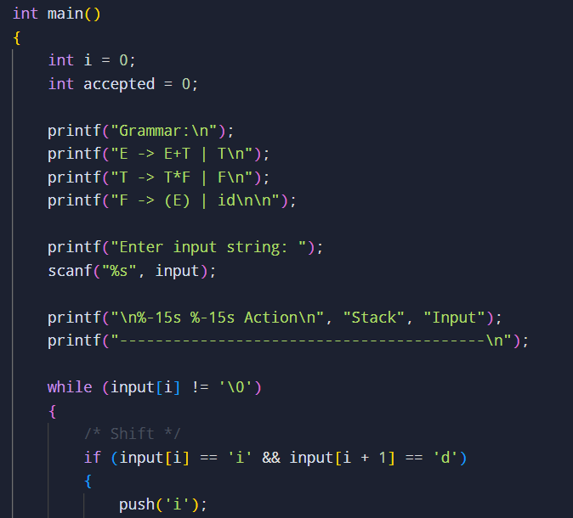
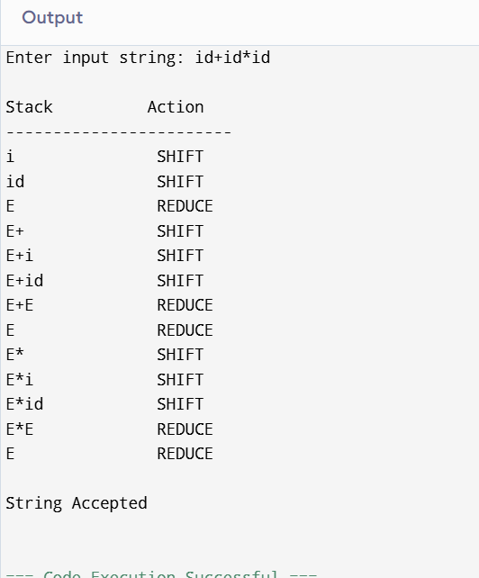
Exp. No. 15
Write a C Program to implement the operator precedence parsing.
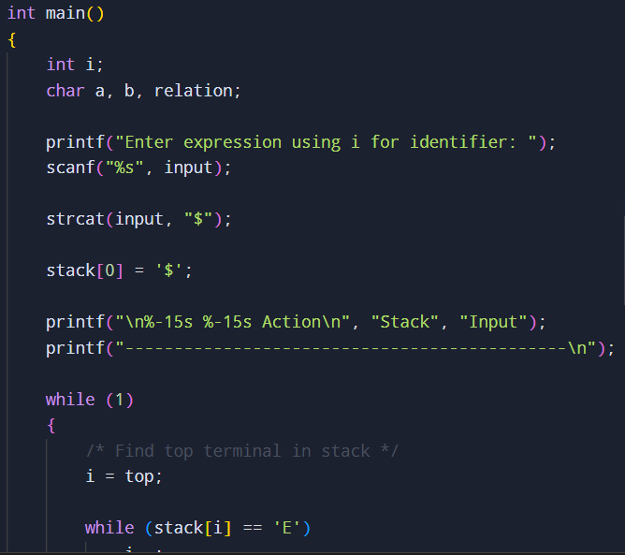
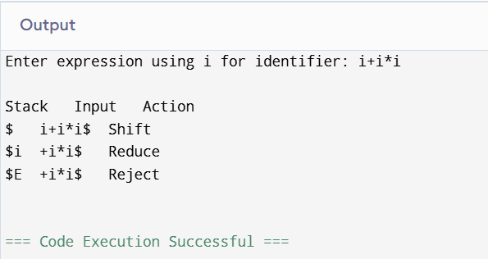

Exp.no16
Write a C Program to Generate the Three address code representation for the given input statement.
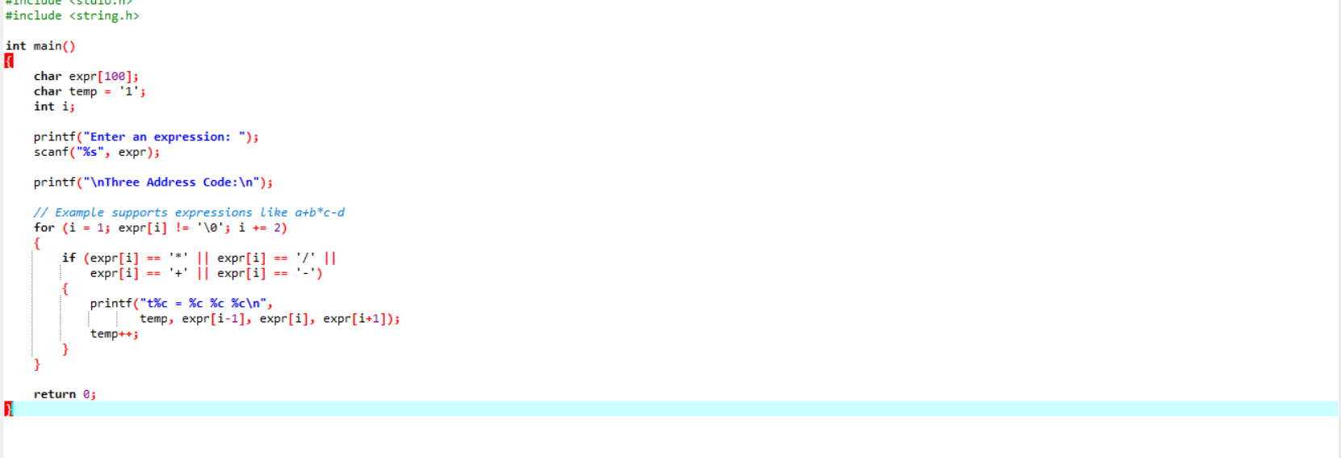

Output:
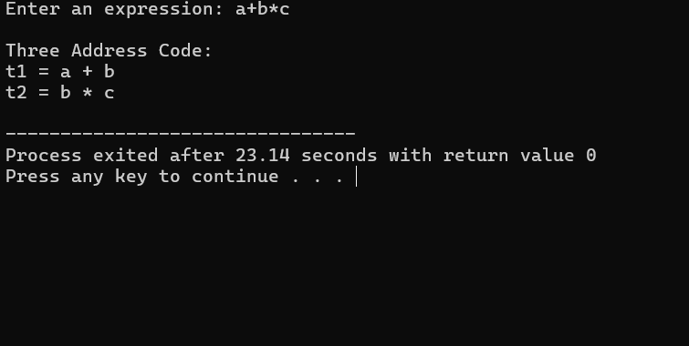

Exp.no17
Write a C program for implementing a Lexical Analyzer to Scan and Count the number of characters, words, and lines in a file.
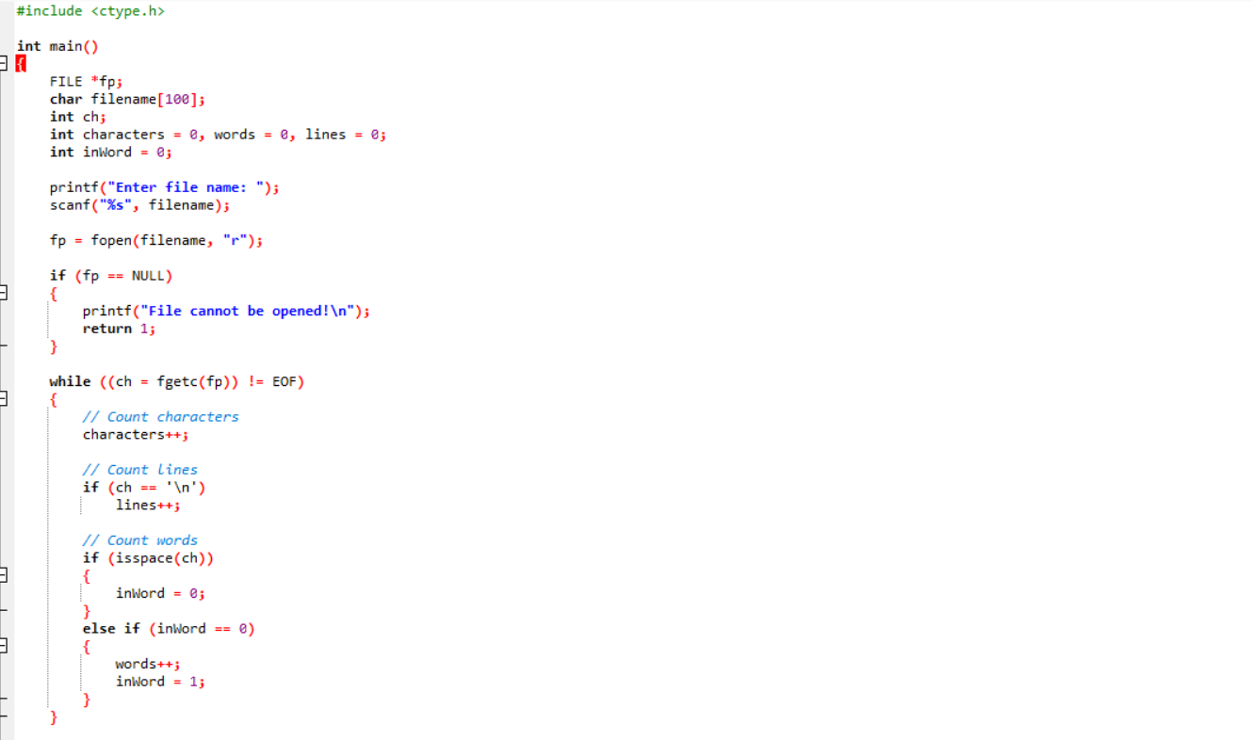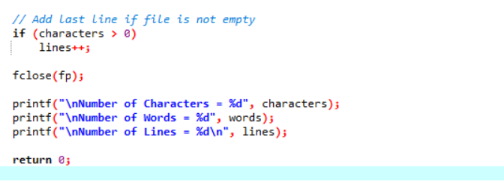

Output:
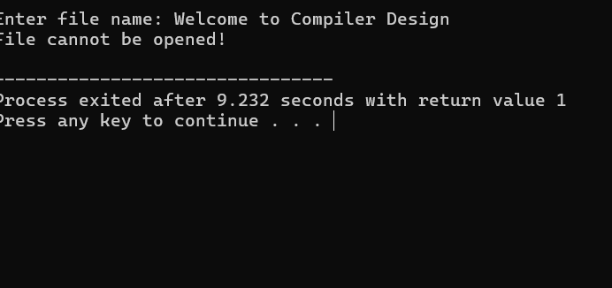

Exp.no18
Write a C program to implement the back end of the compiler.
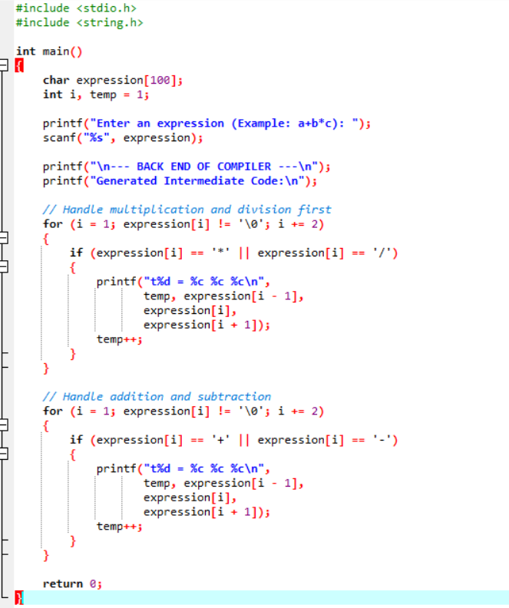

Output:
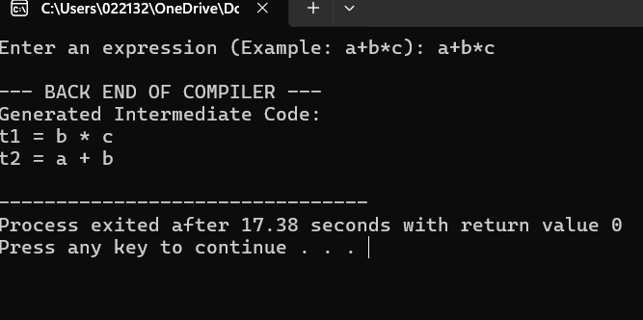

Exp.no19
Write a C program to compute LEADING( ) – operator precedence parser for the given grammar
E → E + T | T
T → T * F | F
F → ( E ) | id
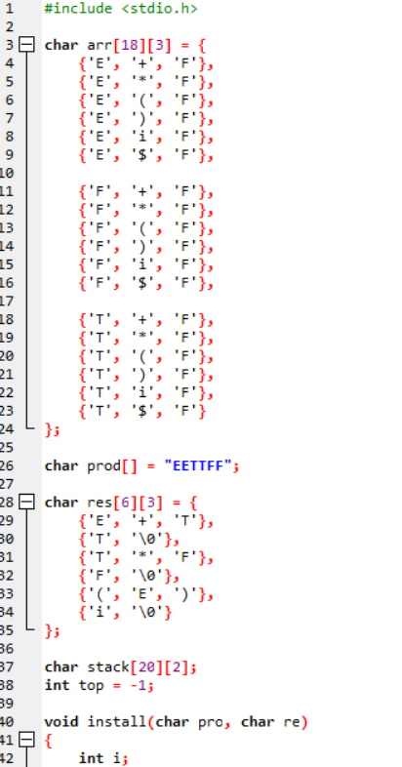
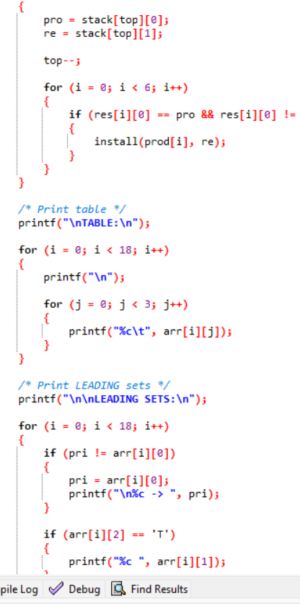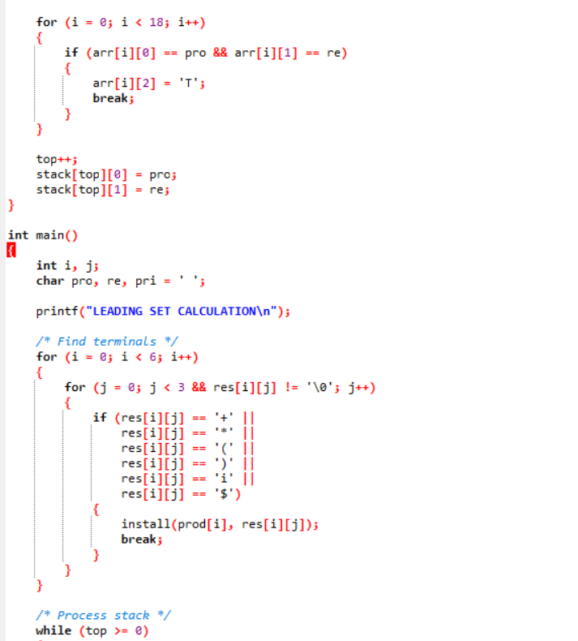
Output:
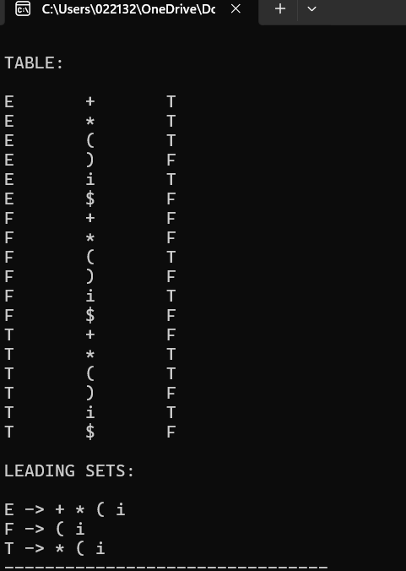

Exp.no 20
Write a C program to compute TRAILING( ) – operator precedence parser for the given grammar
E → E + T | T
T → T * F | F
F → ( E ) | id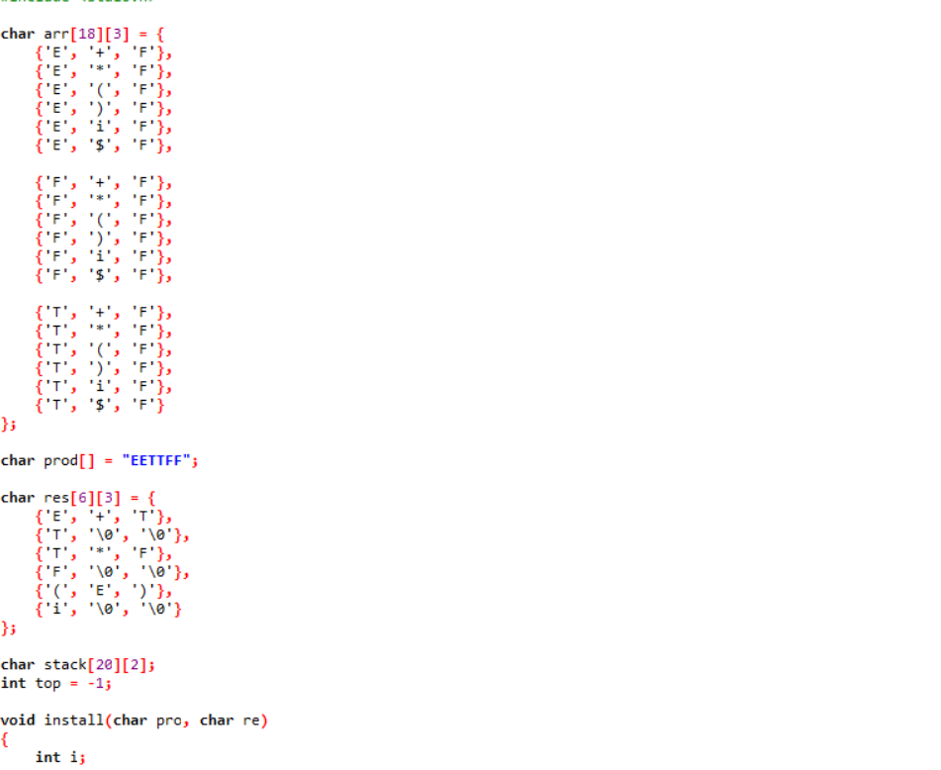 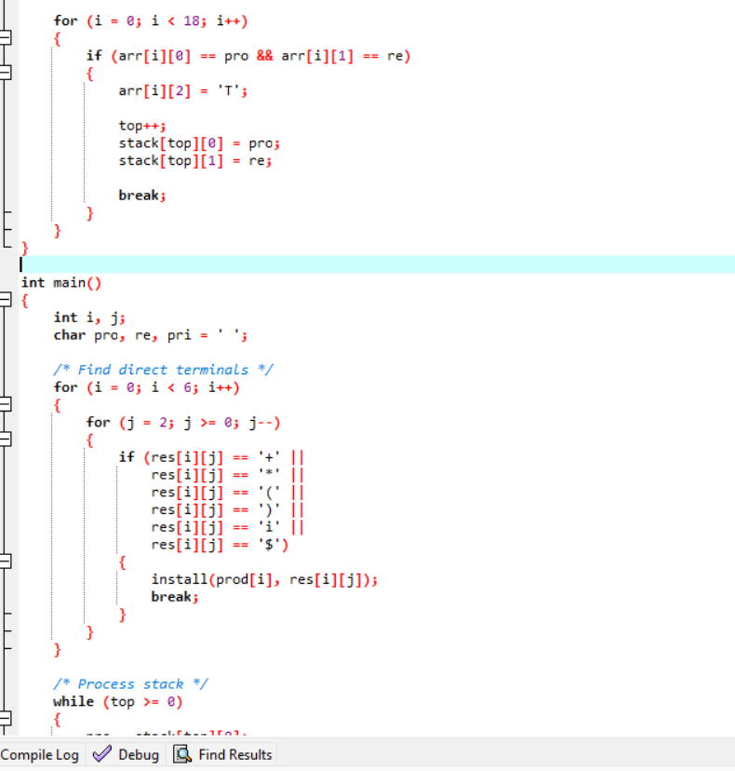 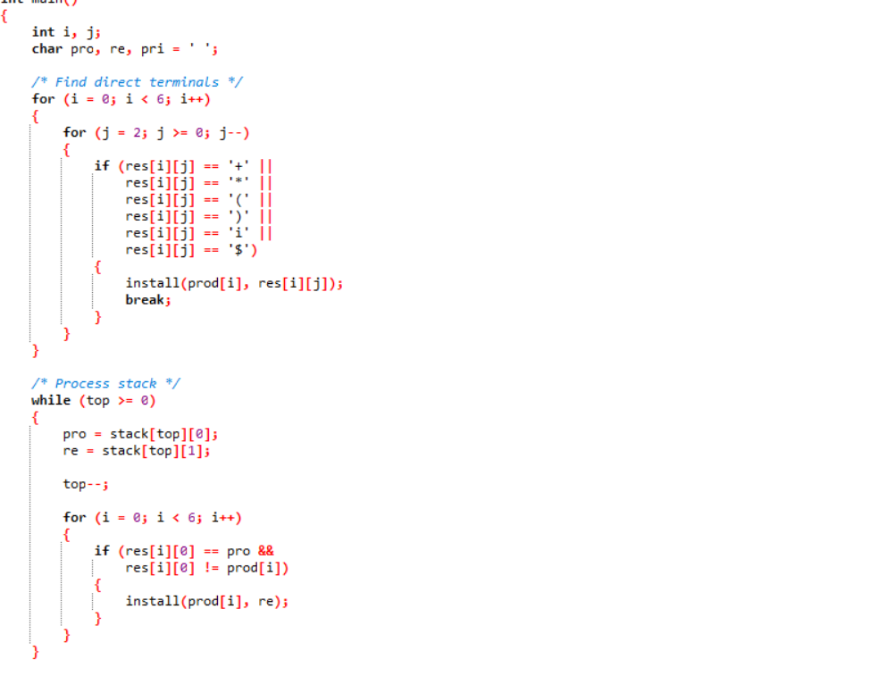
Output:
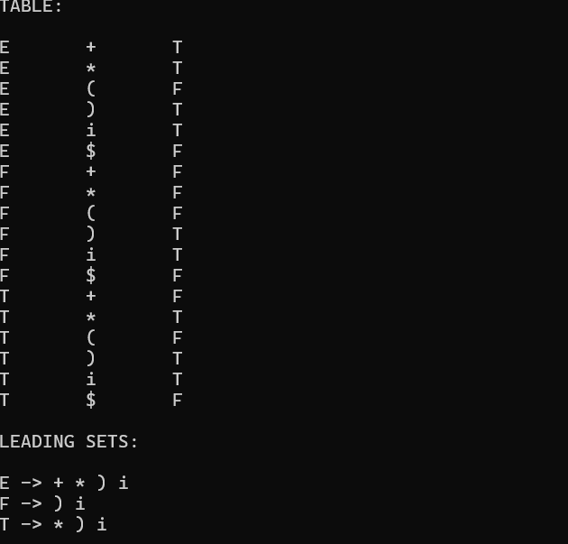

Exp.no21
Write a LEX specification file to take input C program from a .c file and count tthe number of characters, number of lines & number of words.
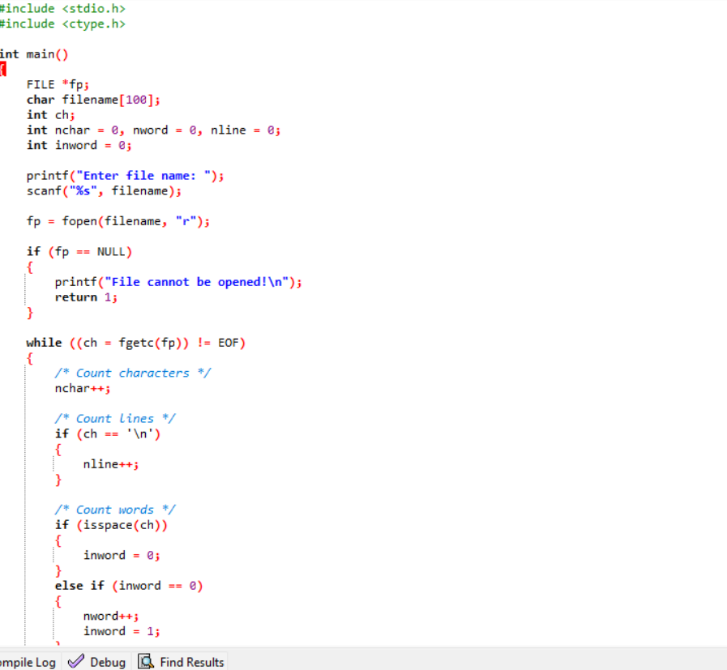
Output:
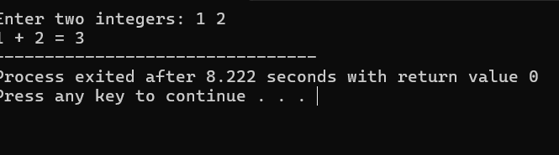

Exp.no22
Write a LEX program to print all the constants in the given C source program file.
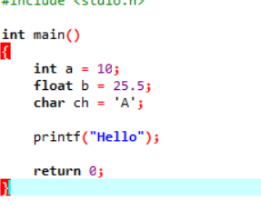
Output:
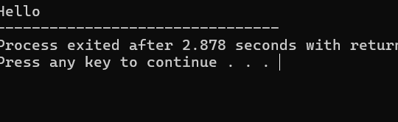

Exp.no23
Write a LEX program to count the number of Macros defined and header files included in the C program
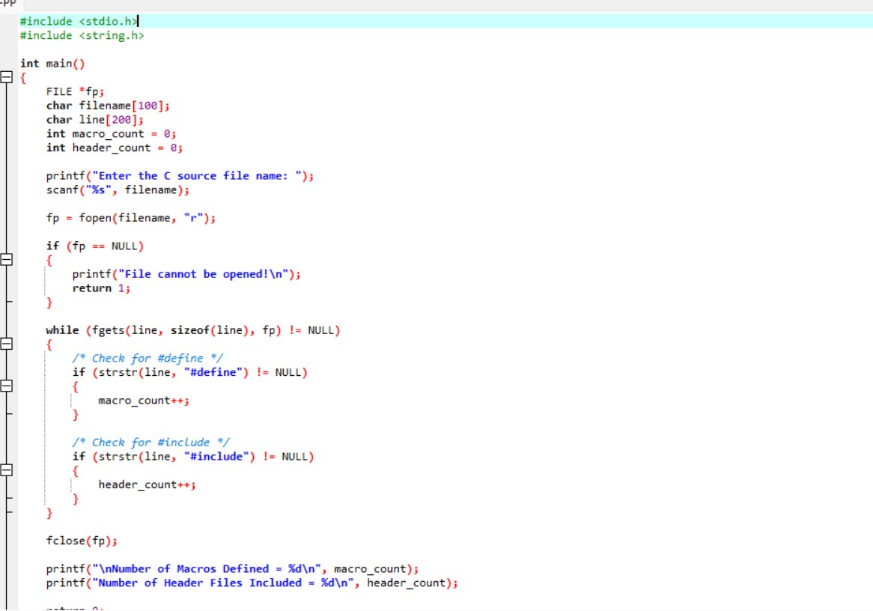
Output:
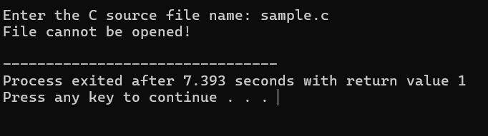

Exp.no24
Write a LEX program to print all HTML tags in the input file.
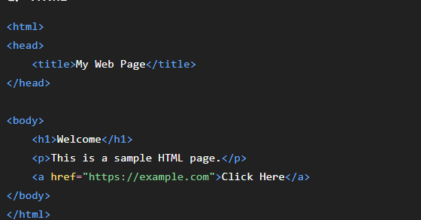

Output:
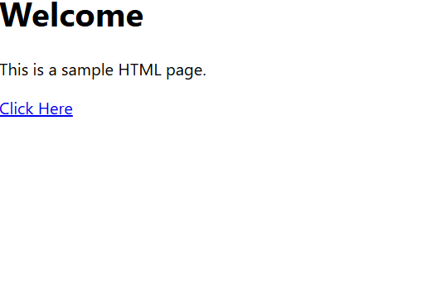

Exp.no25
Write a LEX program which adds line numbers to the given C program file and display the same in the standard output
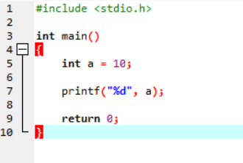

Output:
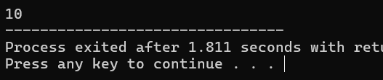

Exp.no26
Write a LEX program to count the number of comment lines in a given C program and eliminate them and write into another file.

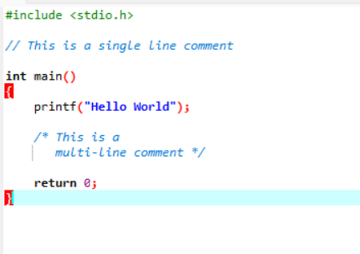
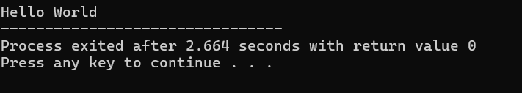
28. Write a LEX Program to check the email address is valid or not.
#include <stdio.h>
#include <string.h>
#include <ctype.h>

int main()
{
char email[100];
int i, at = 0, dot = 0, valid = 1;

printf("Enter Email Address: ");
scanf("%s", email);

for (i = 0; email[i] != '\0'; i++)
{
if (email[i] == '@')
at++;

if (email[i] == '.')
dot++;

if (email[i] == ' ')
valid = 0;
}

/* Check basic email conditions */
if (at != 1)
valid = 0;

if (dot < 1)
valid = 0;

if (email[0] == '@' || email[0] == '.')
valid = 0;

if (email[strlen(email) - 1] == '@' ||
email[strlen(email) - 1] == '.')
valid = 0;

if (valid)
printf("Valid Email Address\n");
else
printf("Invalid Email Address\n");

return 0;
}
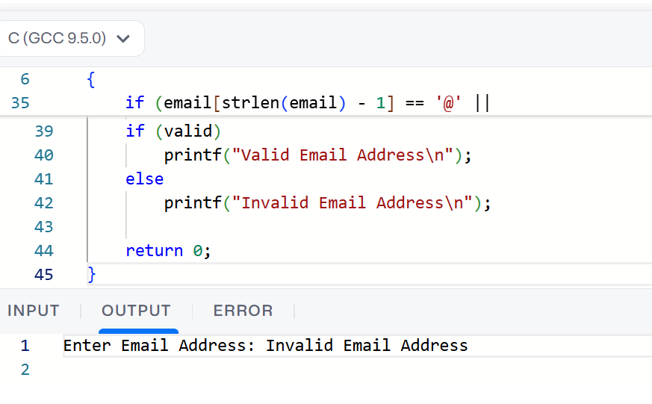

29. Write a LEX Program to convert the substring abc to ABC from the given input string
#include <stdio.h>
#include <string.h>

int main()
{
char str[100];
int i;

printf("Enter a string: ");
fgets(str, sizeof(str), stdin);

for (i = 0; str[i] != '\0'; i++)
{
if (str[i] == 'a' &&
str[i + 1] == 'b' &&
str[i + 2] == 'c')
{
str[i] = 'A';
str[i + 1] = 'B';
str[i + 2] = 'C';

i = i + 2;
}
}

printf("Output: %s", str);

return 0;
}
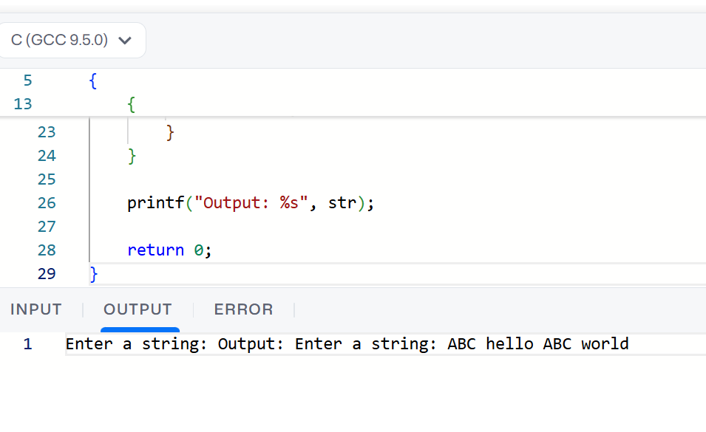

30. Implement a LEX program to check whether the mobile number is valid or not.
#include <stdio.h>
#include <string.h>

int main()
{
char mobile[20];
int i, valid = 1;

printf("Enter Mobile Number: ");
scanf("%s", mobile);

/* Check exactly 10 digits */
if (strlen(mobile) != 10)
{
valid = 0;
}

/* Check first digit */
if (mobile[0] < '6' || mobile[0] > '9')
{
valid = 0;
}

/* Check all characters are digits */
for (i = 0; i < 10; i++)
{
if (mobile[i] < '0' || mobile[i] > '9')
{
valid = 0;
break;
}
}

if (valid)
printf("Valid Mobile Number\n");
else
printf("Invalid Mobile Number\n");

return 0;
}
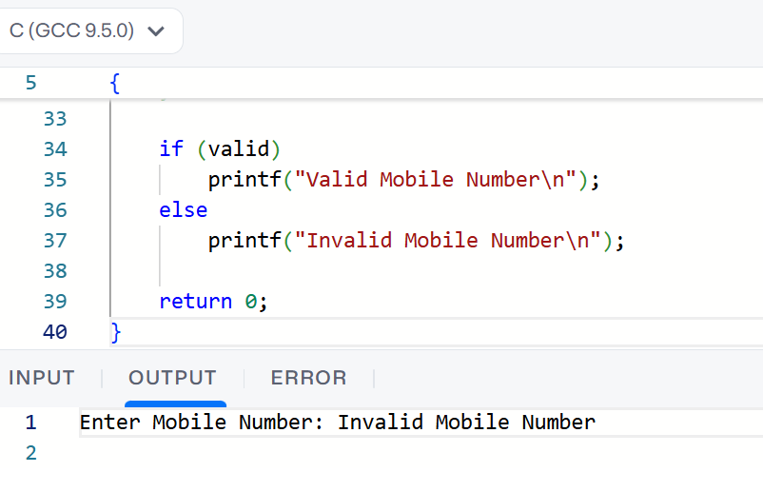

31. Implement Lexical Analyzer using FLEX (Fast Lexical Analyzer). The program should separate the tokens in the given C program and display with appropriate caption.
#include <stdio.h>
#include <string.h>
#include <ctype.h>

int isKeyword(char str[])
{
char keywords[][10] = {
"int", "float", "char", "double",
"if", "else", "for", "while",
"return", "void"
};

int i;

for (i = 0; i < 10; i++)
{
if (strcmp(str, keywords[i]) == 0)
return 1;
}

return 0;
}

int main()
{
char ch, word[50];
int i = 0;

printf("LEXICAL ANALYZER\n");
printf("-----------------\n");
printf("Enter a C program:\n\n");

while ((ch = getchar()) != EOF)
{
/* Identifier or Keyword */
if (isalpha(ch) || ch == '_')
{
i = 0;

while (isalnum(ch) || ch == '_')
{
word[i++] = ch;
ch = getchar();
}

word[i] = '\0';

if (isKeyword(word))
printf("KEYWORD : %s\n", word);
else
printf("IDENTIFIER : %s\n", word);

ungetc(ch, stdin);
}

/* Number */
else if (isdigit(ch))
{
i = 0;

while (isdigit(ch))
{
word[i++] = ch;
ch = getchar();
}

word[i] = '\0';

printf("NUMBER : %s\n", word);

ungetc(ch, stdin);
}

/* Operators */
else if (ch == '+' || ch == '-' || ch == '*' ||
ch == '/' || ch == '=' || ch == '<' ||
ch == '>')
{
printf("OPERATOR : %c\n", ch);
}

/* Special Symbols */
else if (ch == ';' || ch == ',' || ch == '(' ||
ch == ')' || ch == '{' || ch == '}' ||
ch == '[' || ch == ']')
{
printf("SPECIAL SYMBOL : %c\n", ch);
}

/* Ignore spaces */
else if (isspace(ch))
{
continue;
}

else
{
printf("UNKNOWN : %c\n", ch);
}
}

return 0;
}
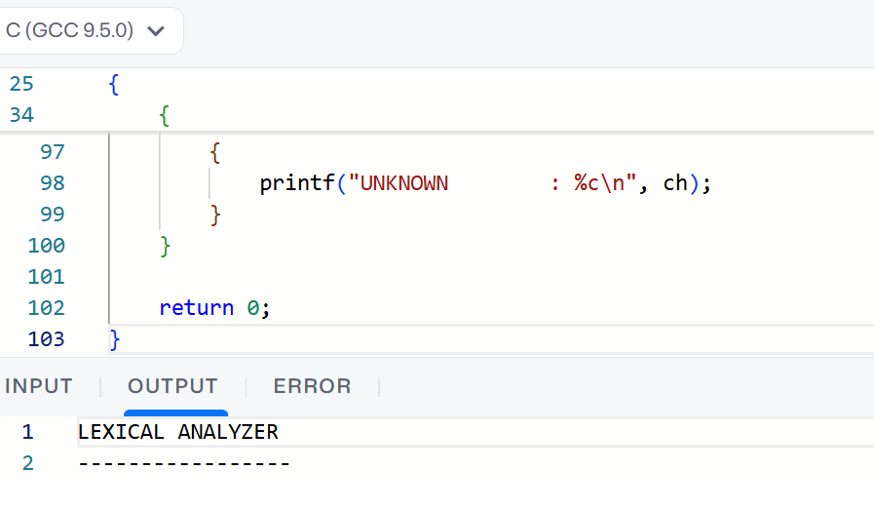

32. Write a LEX program to count the number of vowels in the given sentence
#include <stdio.h>

int main()
{
char str[100];
int i, count = 0;

printf("Enter a sentence: ");
fgets(str, sizeof(str), stdin);

for (i = 0; str[i] != '\0'; i++)
{
if (str[i] == 'a' || str[i] == 'e' || str[i] == 'i' ||
str[i] == 'o' || str[i] == 'u' ||
str[i] == 'A' || str[i] == 'E' || str[i] == 'I' ||
str[i] == 'O' || str[i] == 'U')
{
count++;
}
}

printf("Number of vowels = %d\n", count);

return 0;
}
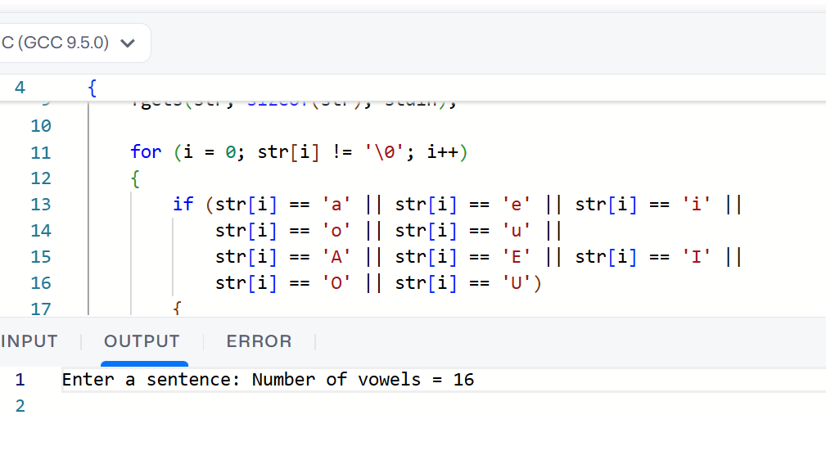
33. Write a LEX program to count the number of vowels in the given sentence.
#include <stdio.h>

int main()
{
char str[100];
int i, count = 0;

printf("Enter a sentence: ");
fgets(str, sizeof(str), stdin);

for (i = 0; str[i] != '\0'; i++)
{
if (str[i] == 'a' || str[i] == 'e' || str[i] == 'i' ||
str[i] == 'o' || str[i] == 'u' ||
str[i] == 'A' || str[i] == 'E' || str[i] == 'I' ||
str[i] == 'O' || str[i] == 'U')
{
count++;
}
}

printf("Number of vowels = %d\n", count);

return 0;
}


34. Write a LEX program to separate the keywords and identifiers.
#include <stdio.h>
#include <string.h>
#include <ctype.h>

int main()
{
char str[100];
char *keywords[] = {
"int", "float", "char", "if", "else",
"for", "while", "return"
};

int i, j, isKeyword;

printf("Enter a C statement: ");
fgets(str, sizeof(str), stdin);

char *word = strtok(str, " ;,(){}<>+-=*/\n");

while (word != NULL)
{
isKeyword = 0;

for (i = 0; i < 8; i++)
{
if (strcmp(word, keywords[i]) == 0)
{
isKeyword = 1;
break;
}
}

if (isKeyword)
printf("Keyword : %s\n", word);
else if (isalpha(word[0]) || word[0] == '_')
printf("Identifier : %s\n", word);

word = strtok(NULL, " ;,(){}<>+-=*/\n");
}

return 0;
}
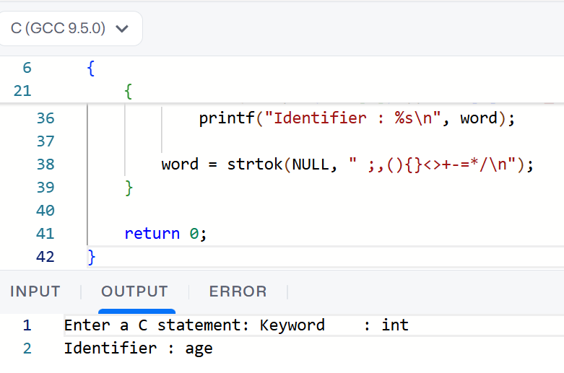

35. Write a LEX program to recognise numbers and words in a statement.
#include <stdio.h>
#include <ctype.h>

int main()
{
char str[100];
int i = 0;

printf("Enter a statement: ");
fgets(str, sizeof(str), stdin);

printf("\nRecognized Tokens:\n");

while (str[i] != '\0')
{
// Recognize words
if (isalpha(str[i]))
{
printf("WORD : ");

while (isalpha(str[i]))
{
printf("%c", str[i]);
i++;
}

printf("\n");
}

// Recognize numbers
else if (isdigit(str[i]))
{
printf("NUMBER : ");

while (isdigit(str[i]))
{
printf("%c", str[i]);
i++;
}

printf("\n");
}

// Ignore spaces
else if (isspace(str[i]))
{
i++;
}

// Other characters
else
{
printf("SPECIAL: %c\n", str[i]);
i++;
}
}

return 0;
}
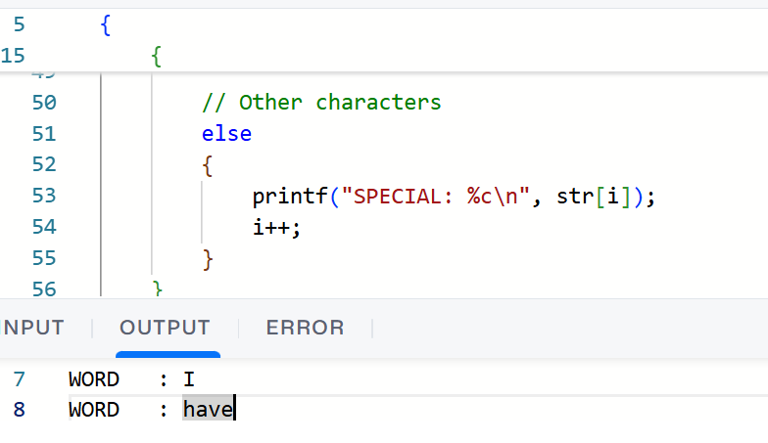

36. Write a LEX program to identify and count positive and negative numbers.
#include <stdio.h>

int main()
{
int n, num;
int positive = 0, negative = 0;

printf("Enter the number of values: ");
scanf("%d", &n);

printf("Enter %d numbers:\n", n);

for (int i = 0; i < n; i++)
{
scanf("%d", &num);

if (num > 0)
{
printf("%d is Positive\n", num);
positive++;
}
else if (num < 0)
{
printf("%d is Negative\n", num);
negative++;
}
else
{
printf("%d is Zero\n", num);
}
}

printf("\nTotal Positive Numbers = %d\n", positive);
printf("Total Negative Numbers = %d\n", negative);

return 0;
}

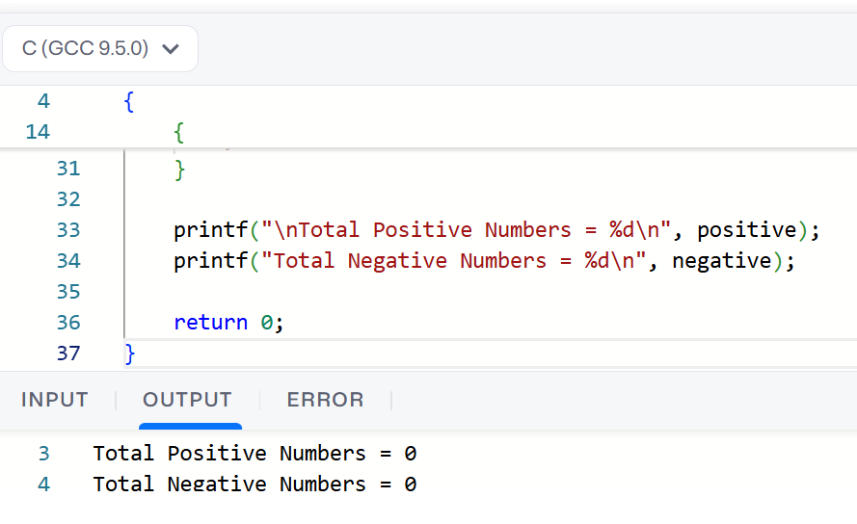

37. Write a LEX program to validate the URL.
#include <stdio.h>
#include <string.h>
#include <regex.h>

int main()
{
char url[200];
regex_t regex;

printf("Enter a URL: ");
scanf("%199s", url);

/*
Pattern checks:
- http:// or https://
- optional www.
- domain name
- .com, .org, .in, etc.
*/
const char *pattern =
"^(http|https)://(www\\.)?[a-zA-Z0-9.-]+\\.[a-zA-Z]{2,}(/.*)?$";

regcomp(&regex, pattern, REG_EXTENDED);

if (regexec(&regex, url, 0, NULL, 0) == 0)
printf("Valid URL\n");
else
printf("Invalid URL\n");

regfree(&regex);

return 0;
}
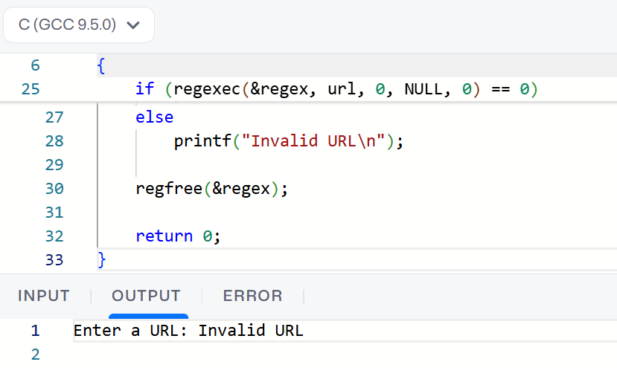

38. Write a LEX program to validate DOB of students.
#include <stdio.h>

int main()
{
int day, month, year;

printf("Enter Date of Birth (DD/MM/YYYY): ");
scanf("%d/%d/%d", &day, &month, &year);

if (day >= 1 && day <= 31 &&
month >= 1 && month <= 12 &&
year >= 1900 && year <= 2026)
{
printf("Valid Date of Birth\n");
}
else
{
printf("Invalid Date of Birth\n");
}

return 0;
}
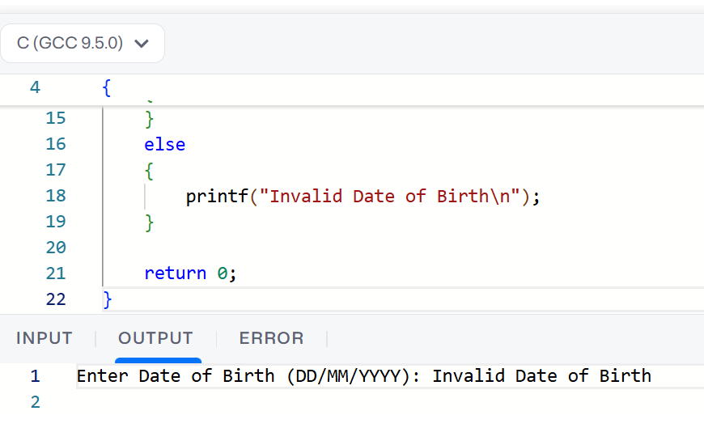

39.Write a LEX program to check whether the given input is digit or not.
#include <stdio.h>

int main()
{
char ch;

printf("Enter a character: ");
scanf("%c", &ch);

if (ch >= '0' && ch <= '9')
printf("Given input is a digit");
else
printf("Given input is not a digit");

return 0;
}
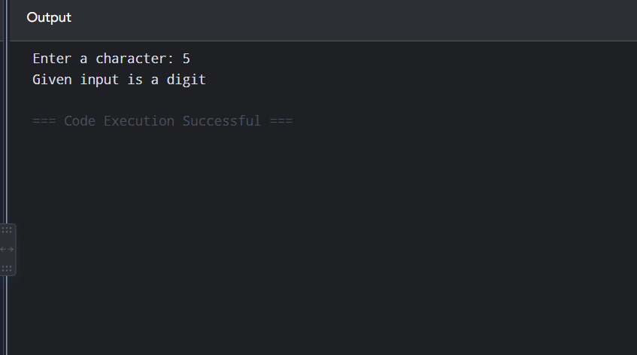

40. Write a LEX program to implement basic mathematical operations.
#include <stdio.h>

int main()
{
int a, b;
char op;

printf("Enter two numbers and an operator: ");
scanf("%d %c %d", &a, &op, &b);

switch(op)
{
case '+':
printf("Result = %d", a + b);
break;

case '-':
printf("Result = %d", a - b);
break;

case '*':
printf("Result = %d", a * b);
break;

case '/':
if (b != 0)
printf("Result = %d", a / b);
else
printf("Division by zero is not possible");
break;

default:
printf("Invalid operator");
}

return 0;
}
